UNIT 2
Chapter 1: 2D Transformation

- INTRODUCTION TO TRANSFORMATION
In computer graphics we often require to transform the coordinates of an object (position, orientation and size). One can view object transformation in two complementary ways:
(i) Geometric transformation: Object transformation takes place in relatively stationary coordinate system or background.
(ii) Coordinate transformation: In this view point, coordinate system is transformed instead of object.
On the basis of preservation, there are three classes of transformation
· Rigid body: Preserves distance and angle. Example –translation and rotation
· Conformal: Preserves angles. Example- translation, rotation and uniform scaling
· Affine: Preserves parallelism, means lines remains lines.
Example- translation, rotation, scaling, shear and reflection
In general there are four attributes of an object that may be transformed
(i) Position (translation)
(ii) Size (scaling)
(iii)Orientation (rotation)
(iv) Shapes (shear)
(v)Objects (Reflection)
- TRANSFORMATION MATRIX
- Transformation matrix is a basic tool for transformation.
- A matrix with n m dimensions is multiplied with the coordinate of objects. Usually 3 3 or 4 4 matrices are used for transformation.
- For example consider the following matrix for rotation operation
TYPES OF TRANSFORMATION IN TWO –DIMENSIONAL GRAPHICS
In 2D transformations, only planar coordinates are used. For this purpose a 2x2 transformation matrix is utilized. In general,
2D transformation includes following types of transformations:
I. Identity transformation
II. Scaling
III. Reflection
IV. Shear transformation
V. Rotation
VI. Translation
- IDENTITY TRANSFORMATION
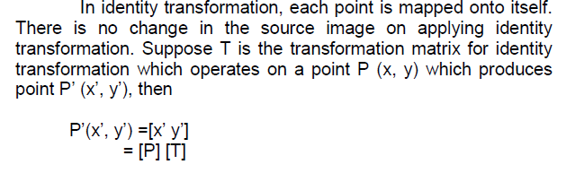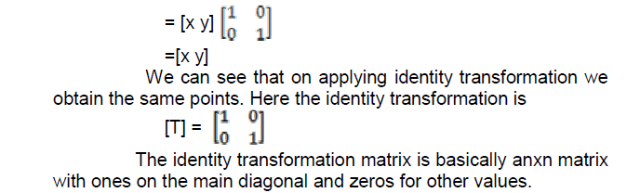
- SCALING TRANSFORMATION
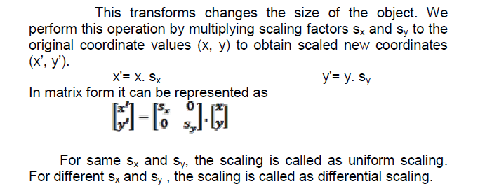
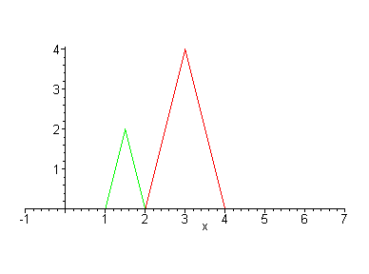
- Scaling in X direction
- Consider a case where $a=Sx≠0$
$b=c=0$
$d=1$
Scaling factor in x direction is given by $Tsx=\left[\begin{matrix}Sx & 0 \\ 0 & 1\end{matrix}\right]$
Transformation point $P^{'}\left(x^{'}y^{'}\right)=P^{'}\left[x^{'}y^{'}\right]=\left[P\right][Tsx]$
$=[x y]$ $\left[\begin{matrix}Sx & 0 \\ 0 & 1\end{matrix}\right]$
$=[xSx$ y]
$$∴x^{'}=xSx and y^{'}=y$$
- Scaling in Y direction
- Consider a case where $a=$ 1 $b=c=0$
$d=Sy≠0$
Scaling factor in y direction is given by $Tsy=\left[\begin{matrix}1 & 0 \\ 0 & Sy\end{matrix}\right]$
Transformation point $P^{'}\left(x^{'}y^{'}\right)=P^{'}\left[x^{'}y^{'}\right]=\left[P\right][Tsy]$
$=[x y]$ $\left[\begin{matrix}1 & 0 \\ 0 & Sy\end{matrix}\right]$
$=[x$ ySy]
$$∴x^{'}=x and y^{'}=ySy$$
- Scaling in X and Y both direction
- Consider a case where $a=Sx≠0$
$b=c=0$
$d=Sy≠0$
Scaling factor in x and y direction is given by $Tsx=\left[\begin{matrix}Sx & 0 \\ 0 & Sy\end{matrix}\right]$
Transformation point $P^{'}\left(x^{'}y^{'}\right)=P^{'}\left[x^{'}y^{'}\right]$
$=\left[P\right][Tsx Tsy]$
$=[x y]$ $\left[\begin{matrix}Sx & 0 \\ 0 & Sy\end{matrix}\right]$
$=[xSx$ ySy]
$∴x^{'}=xSx and y^{'}=y$Sy
- REFLECTION TRANSFORMATION
- Reflection is a transformation that converts each point in the plane to its mirror image with respect to the plane in space.
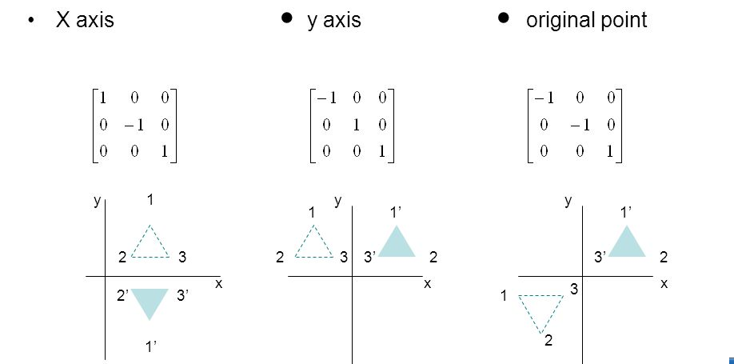
1.Reflection about X axis
- Consider a case where $a=1,b=c=0, d=-1$
Reflection transformation matrix is given by $TRx=\left[\begin{matrix}1 & 0 \\ 0 & -1\end{matrix}\right]$
Transform point is given by $P^{'}$(x’ y’)=P’[x’ y’]
=[P]$\left[TRx\right]$
$=[x y]\left[\begin{matrix}1 & 0 \\ 0 & -1\end{matrix}\right]$
$$=\left[x -y\right]$$
$$∴x^{'}=x and y^{'}=-y$$
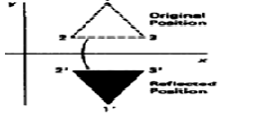

2.Reflection about Y axis
- Consider a case where $a=-1,b=c=0, d=1$
Reflection transformation matrix is given by $TRy=\left[\begin{matrix}-1 & 0 \\ 0 & 1\end{matrix}\right]$
Transform point is given by $P^{'}$(x’ y’)= P’[x’ y’]
= [P]$\left[TRy\right]$
$=[x y]\left[\begin{matrix}-1 & 0 \\ 0 & 1\end{matrix}\right]$
$$=\left[-x y\right]$$
$$∴x^{'}=-x and y^{'}=y$$
3.Reflection about origin
- Consider a case where $a=-1,b=c=0, d=-1$
Reflection transformation matrix is given by $TRo=\left[\begin{matrix}-1 & 0 \\ 0 & -1\end{matrix}\right]$
Transform point is given by $P^{'}$(x’ y’)=P’[x’ y’]
=[P]$\left[TRo\right]$
$=[x y]\left[\begin{matrix}-1 & 0 \\ 0 & -1\end{matrix}\right]=\left[-x -y\right]$
$$∴x^{'}=-x and y^{'}=-y$$
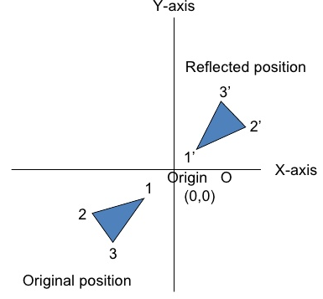
- SHEAR TRANSFORMATIONS
- shearing is a deformation of an object in which parallel phases remain parallel but are shifted in a direction parallel to them.
$T=\left[\begin{matrix}a & b \\ c & d\end{matrix}\right]$
$Tsh=\left[\begin{matrix}1 & Shy \\ Shx & 1\end{matrix}\right]$ Where Shx and Shy are shearing factors.
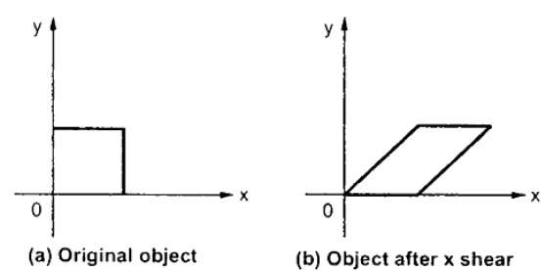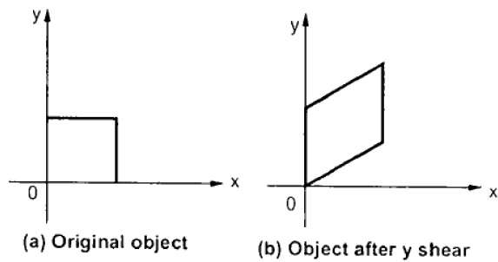
1.Shearing in positive X direction
- Consider a case $Shy=0 \& Shx=1$
$$∴Tshx=\left[\begin{matrix}1 & 0 \\ 1 & 1\end{matrix}\right]$$
$∴transformation point given by$ $P^{'}\left(x^{'}y^{'}\right)=P^{'}\left[x^{'}y^{'}\right]$
$=\left[P\right][Tshx]$
= $[x y]$ $\left[\begin{matrix}1 & 0 \\ 1 & 1\end{matrix}\right]$
$=[x+y y]$ $∴x^{'}=x+y \& y^{'}=y$
2. Shearing in negative X direction
- Consider a case $Shy=0 \& Shx=-1$
$$∴Tshx=\left[\begin{matrix}1 & 0 \\ -1 & 1\end{matrix}\right]$$
$∴transformation point given by$ $P^{'}\left(x^{'}y^{'}\right)=P^{'}\left[x^{'}y^{'}\right]$
$=\left[P\right][Tshx]$
= $[x y]$ $\left[\begin{matrix}1 & 0 \\ -1 & 1\end{matrix}\right]$
$=[x-y y]$
$$∴x^{'}=x-y \& y^{'}=y$$
3.Shearing in positive Y direction
- Consider a case $Shy=1 \& Shx=0$
$$∴Tshy=\left[\begin{matrix}1 & 1 \\ 0 & 1\end{matrix}\right]$$
$∴transformation point given by$ $P^{'}\left(x^{'}y^{'}\right)=P^{'}\left[x^{'}y^{'}\right]$
$=\left[P\right][Tshy]$
= $[x y]$ $\left[\begin{matrix}1 & 1 \\ 0 & 1\end{matrix}\right]$
$=[x x+y]$
$$∴x^{'}=x \& y^{'}=x+y$$
4.Shearing in negative Y direction
- Consider a case $Shy=0 \& Shx=-1$
$$∴Tshy=\left[\begin{matrix}1 & -1 \\ 0 & 1\end{matrix}\right]$$
$∴transformation point given by$ $P^{'}\left(x^{'}y^{'}\right)=P^{'}\left[x^{'}y^{'}\right]$
$=\left[P\right][Tshy]$
= $[x y]$ $\left[\begin{matrix}1 & -1 \\ 0 & 1\end{matrix}\right]$
$=[x -x+y]$ $∴x^{'}=x \& y^{'}=-x+y$
- ROTATION TRANSFORMATION
- Rotation can be performed in two ways: about origin or about an arbitrary point called as rotation point or pivot point.
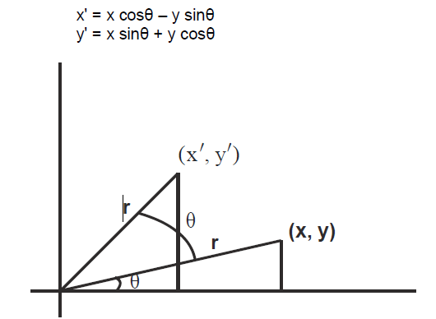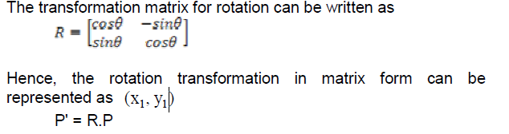
Let point P (x, y) be any point in the co-ordinate system which makes an angle $∅$with x axis. Let point P(x, y) be rotated by an angle of $θ$ to point P’(x’, y’). the distance of the point P and P’ from the origin be radius(r).
In $∆POR$
$sin∅{=y/r}$ $∴y=r\sin{∅}$ ---------------equ 1
$\cos{∅=x/r}$ $∴x =r cos∅$ ---------------equ 2
In $∆P'OR$
$sin(∅+θ){=y'/r}$ $∴$ $y'=r\sin{(∅+θ)}$
$$y'=r(sin∅.cosθ+cos∅.sinθ)$$
$$y'=(rsin∅).cosθ+(rcos∅).sinθ$$
Y’$=ycosθ+xsinθ$…….from eqa 1 and 2
$\cos{(∅+θ)=x'/r}$ $∴x'=rcos(∅+θ)$
$$x'=r(cos∅.cosθ-sin∅.sinθ)$$
$$x^{'}=\left(rcos∅\right).cosθ-(rsin∅).sinθ$$
x’$=xcosθ-ysinθ$…….from eqa 1 and 2
$$P^{'}\left(x^{'}y^{'}\right)=P^{'}\left[x^{'}y^{'}\right][xcosθ -ysinθ ycosθ+xsinθ]$$
$=[x y]\left[\begin{matrix}cosθ & sinθ \\ -sinθ & cosθ\end{matrix}\right]$
$=[xcosθ-ysinθ xsinθ+ycosθ]$
$$=\left[P\right][TRθ]$$
Where$TRθ is callede as rotation transformation matrix$.
$TRθ=\left[\begin{matrix}cosθ & sinθ \\ -sinθ & cosθ\end{matrix}\right]$ Anticlock wise direction
$TRθ=\left[\begin{matrix}cosθ & -sinθ \\ sinθ & cosθ\end{matrix}\right]$ clock wise direction

- TRANSLATION TRANSFORMATION
